

**Full company name:** Tafauti Infrastructure Nigeria Limited

**Hometown and country of company:** Abuja, Nigeria

**Tax registration number (Tax Identification Number – TIN):** 18579529

**Owner of company (all shareholders):** Yahaya Yunana and Matitiya Yunana (to be expanded later)

**Number of full-time employees[1]:** 35 at full capacity

**Mail address:** CSF02, K City Plaza, Plot 528 Aminu Kano Crescent, Wuse Zone 2, Abuja, Nigeria

**web-address (if applicable):** No website

## 

Table of contents

Company presentation

Vision/Mission

Main revenue streams

12-36 months objectives

How does your business contribute to a flourishing local community?

Community / Family / Self (What impact does your business have on the world around you, can it contribute to achieve a flourishing Africa)

Financial performance

CONSOLIDATED SUMMARY BALANCE SHEET

Risk Analysis

Details of the loan

Foreign bank transactions

Additional information requested

Questions and Answers

# Company Presentation

The core business is production of aggregates for the construction industry, by operating a granite quarry where granite is crushed and sold to end users (contractors and home builders) for use in construction projects. Product sizes consist of 4 standard sizes, with provision for on demand sizes.

Nigeria has a massive infrastructure deficit with 17.37 million housing deficit and 197,000kms roads with only 18% is paved, accounting for about 90% of traffic. Aggregates has application in the infrastructure/construction industry. Aggregates make up 94% of asphalt pavement and 80% of concrete roads, and seats at the core of the construction industry. Nigeria’s estimated infrastructure needs amounts to $12.6-21 billion (3-5% of GDP) annually. Figures 1 and 2 shows Nigeria’s dismal position and the significant infrastructure investment scope. Our motivation is to make an ethical difference in the marketplace, increase local participation and generate economic activity in hitherto low activity Christian dominated communities.

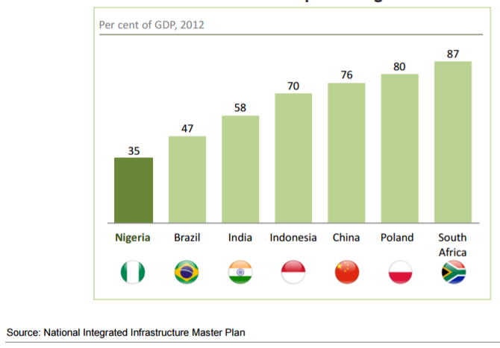

*Fig. 1 Contribution of Infrastructure to GDP of peer countries*

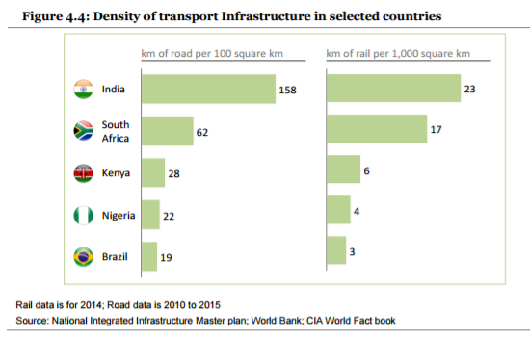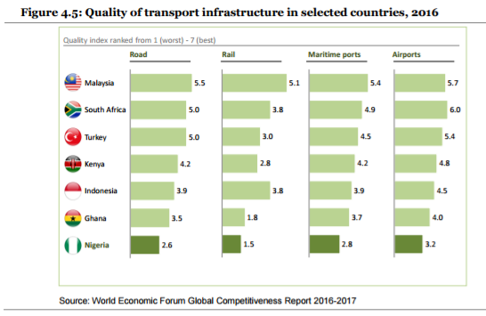

*Fig. 2: Density and Quality of Nigeria Transport Infrastructure compared to Peer Countries*

# Vision/Mission

**Vision:** Outthink, Outperform.

**Mission Statement:** We will develop and leverage local talent to outthink and outperform the competition, create targeted value for our stakeholders (employees, customers, society, investors, government, etc.) and make a difference in the construction materials marketplace.

**Core Values:**

* **Sustainability** – environmental, economic and social
* **Courage** to go beyond comfort zone and not afraid to fail
* **Integrity** – Honest and reliable
* **Team working** – Respect for others
* **Excellence** through creativity and Innovation in an entrepreneurial ecosystem

# Main revenue streams

**Short Term**

1. Achieve mastery in the production and sale of aggregates to Infrastructure/Construction projects contractors and individuals constructing own homes, from a commercial and captive on demand (contract) quarries on a cash and carry basis. The aggregates production will provide a platform for added value products (concrete batching/products - bricks, transmission poles and asphalt.

**Medium/Long Term**

1. Concrete plant/batching

2. Asphalt plant/batching

3. Bricks, paving tiles for road construction and concrete poles for electricity transmission

4. Dimension stones

# 12-36 months objectives*

The objectives over the next 3 years is underpinned by the company’s strategy of targeting the core of the construction industry – aggregates, which is the essential and major material in every infrastructure project. Quarrying aggregates unlike mining is a straight forward and relatively efficient operation, compared to mining and is traditionally prepaid. As a deliberate strategy, Tafauti, will focus on the production and sale of aggregates with plans for added value (concrete products and asphalt batching). We will not engage in postpaid contracts.

|  |  |
| --- | --- |
| **Period (Months)** | **Objectives** |
| 0-12  (2017/18) | * Start operations and ramp up to full capacity (300 TPH). * Market development/validate assumptions and update business financials. * Generate demand to create a demand pull. * Implement ERP solution including financials. Deploy processes and systems. * Finalize HR strategy and implement * Commission Feasibility assessment of value added vertical markets (asphalt and concrete batching, brickyard) |
| 12-24  (2018/19) | * Drive and embed production and cost efficiency, up daily production capacity by 20% * Assess prospects of additional stationary crushers to maximize available market * Develop captive on demand quarrying market for major infrastructure projects, leveraging the mobile crushers * Undertake company valuation and take on equity investment * Commission dimension stone feasibility study |
| 24-36  (2019/20) | * If feasible prepare business plan and investment proposal * Raise capital and establish asphalt and/or concrete batching plant(s), brickyard * Consolidate position as preferred supplier of aggregates * Consolidate captive crushing business unit |

* *Business objectives is confidential and not for publication*

# How does your business contribute to a flourishing local community?

## Community / Family / Self (What impact does your business have on the world around you, can it contribute to achieve a flourishing Africa).

## The quarry industry in the operational area are dominated by foreign companies. Tafauti will be a major indigenous player, in the industry.

## When fully resourced, the company will directly employ about 35 people and we have a deliberate policy to consider qualified people in the neighboring communities. All staff except one will reside in the community.

## Graduate trainee engineers scheme will help build human capital.

## Development of talent pipeline and Mentoring, in the company and through Itzinya Start Up Academy.

## Products distributorship and outsourcing of some services will be offered to competent members of the host communities.

## A deliberate effort to support human capital capacity building through scholarships, youth camps in collaboration with The Navigators and Harvest Leaders Network, by leveraging existing infrastructure in their networks.

## Construction and maintenance of a 1.45km access road, opening up the area for future development. The road may in the future be tarred.

1. **Environmental Sustainability:** Our environmental safety commitments are:
   1. Operate in an environmentally sustainable way. An environmental management plan study is in process. An environmental policy on waste discharge and management will be in place and accounted for, supported by a HSE Officer.
   2. All operations will be done taking cognizance of sustainable practices and an environmental monitoring plan will be in place.
   3. Blasting will be designed to cause the least environmental impact and quarry pits will be reclaimed for alternate uses at the end.
   4. We are developing an energy plan targeted at efficiency and reduced carbon footprint by getting the right energy mix. For instance, we plan to use solar to power floodlights at the site.
2. **Missional (how can your business contribute to spreading the gospel?):** We are committed to supporting missions (reaching the unreached and discipleship), which the company’s founders having been supporting as individuals. Part of the burden and mission of the company is to be biblical and support missions, given the appalling needs, in areas like:
   1. Operating based on biblical principles in the marketplace. A servant leadership framework will be operated, Harvest Leadership Network Nigeria in collaboration with Co-Serve International has agreed to provide training, support and network support from servant leadership managed company. HR policies will be underpinned by servant leadership principles.
   2. Port Harcourt NAV ministry center project (staff housing and office facility), Workplace ministry and NAV staff support.
   3. Calvary Ministry (CAPRO <http://capromissions.org/history/> ) missionaries, reaching the unreached in frontier areas.
   4. Workplace and discipleship ministry in the company and community

# Financial Performance Forecast

Given that the business has no financial history, the financial information are from the forecast. The assumptions and risking of the numbers have been outlined in the other related documents. All figures are quoted in USD, converted from NGN at the rate of 360/$1 – Table 1:

*Table 1 – Financial Forecast in USD*

|  |  |  |  |  |
| --- | --- | --- | --- | --- |
| **YEAR/KPI** | **2021** | **2020** | **2019** | **2018** |
| REVENUE | 3,617,827.29 | 3,617,827.29 | 3,405,013.92 | 2,893,864.05 |
| EBITDA | 1,695,806.39 | 1,778,924.19 | 1,687,266.28 | 994,370.54 |
| NET PROFIT | 813,261.62 | 837,429.01 | 761,129.20 | 463,877.97 |

## 

## CONSOLIDATED SUMMARY BALANCE SHEET

All figures are quoted in USD, converted from NGN at the rate of 360/$1:

*Table 2 – Consolidated Balance Sheet in USD*

|  |  |  |  |  |
| --- | --- | --- | --- | --- |
| **YEAR/KPI** | **2021** | **2020** | **2019** | **2018** |
| **ASSETS** | | | | |
| **ASSETS (CURRENT)** | | | | |
| Cash | 5,501,346.04 | 4,073,640.99 | 2,562,818.15 | 1,143,653.21 |
| Accounts Receivable | - | - | - | - |
|  |  |  |  |  |
| **ASSETS (NON CURRENT)** | | | | |
| Plant & Machinery | 140,627.78 | 281,255.56 | 421,883.33 | 562,511.11 |
| Motor Vehicle | 6,666.67 | 13,333.33 | 20,000.00 | 26,666.67 |
| Furniture & Fittings | 666.67 | 1,333.33 | 2,000.00 | 2,666.67 |
| Office Equipment | 666.67 | 1,333.33 | 2,000.00 | 2,666.67 |
|  |  |  |  |  |
| TOTAL ASSETS | **5,649,973.81** | **4,370,896.55** | **3,008,701.48** | **1,738,164.32** |
|  |  |  |  |  |
| **LIABILITIES** | | | | |
| Notes Payable | - | - | - | - |
| Tax Payable | 2,399,276.02 | 1,933,460.37 | 1,408,694.31 | 899,286.35 |
|  |  |  |  |  |
| TOTAL LIABILITIES | 2,399,276.02 | 1,933,460.37 | 1,408,694.31 | 899,286.35 |
|  |  |  |  |  |
| **OWNERS EQUITY** | | | | |
| Capital Stock | 375,000.00 | 375,000.00 | 375,000.00 | 375,000.00 |
| Retained Earnings | 2,875,697.80 | 2,062,436.18 | 1,225,007.17 | 463,877.97 |
|  |  |  |  |  |
| TOTAL OWNERS EQUITY | 3,250,697.80 | 2,437,436.18 | 1,600,007.17 | 838,877.97 |
|  |  |  |  |  |
| TOTAL | **5,649,973.81** | **4,370,896.55** | **3,008,701.48** | **1,738,164.32** |

*The Company is just starting operations, consequently, financial statements for the last three years is not available/applicable.*

# Risk Analysis

In the Nigerian context, there are two levels of risk, Country business and business specific Risk, which have been assessed and mitigations put in place (Risks/Mitigation table). The approach to risk management has been to first systemically embed mitigations into the business model and processes. This is followed by mitigations for the subsisting risk.

Nigeria is a challenging place to do business, because of the obstacles and institutional voids, ranging from difficulties in accessing finance, inefficient bureaucracy, ambiguous and inconsistent policies/regulations, corruption and poor infrastructure. A World Bank Enterprise survey of 2000 small businesses in Nigeria ranks the obstacles (fig. 3). Top level risk of power is mitigated by the use of self-powered crushers, corruption by targeting a segment of the sector that is a cash and carry transaction, with the least involvement with government.

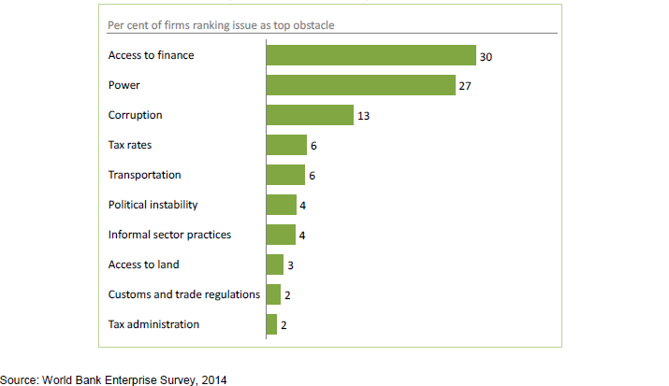

*Fig. 3 - Obstacles to doing business in Nigeria, 2014.*

Business level risk are discussed in table 3.

*Table 3 – Risks Assessment and Mitigations*





# Details of the loan

**Size of requested loan:** $100.000)

**Target payback time:** 4 years

**Target annual interest rate: 20% (thereof 20% is kept by Naventure Nordic as administration fee, meaning invester get (100-20)%*20%=16% annual interest**

**Reasons for applying for a loan:** Acquisition ofEquipment (Capital Expenditure) required to make the quarry operational.

# Foreign Bank Transactions

We are currently processing the opening of a foreign currency (USD) account.

# Additional information requested

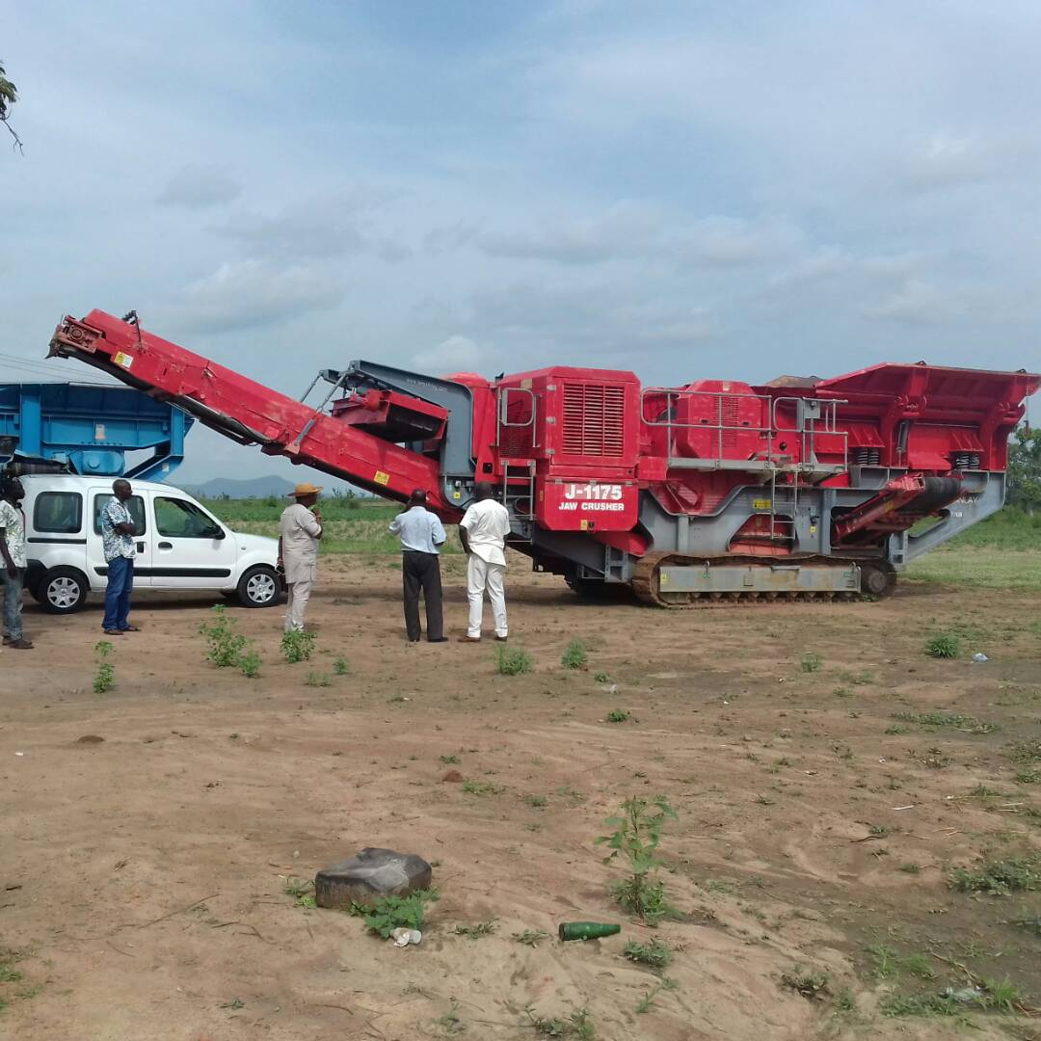

350 TPH Mobile Primary (Jaw) Crusher

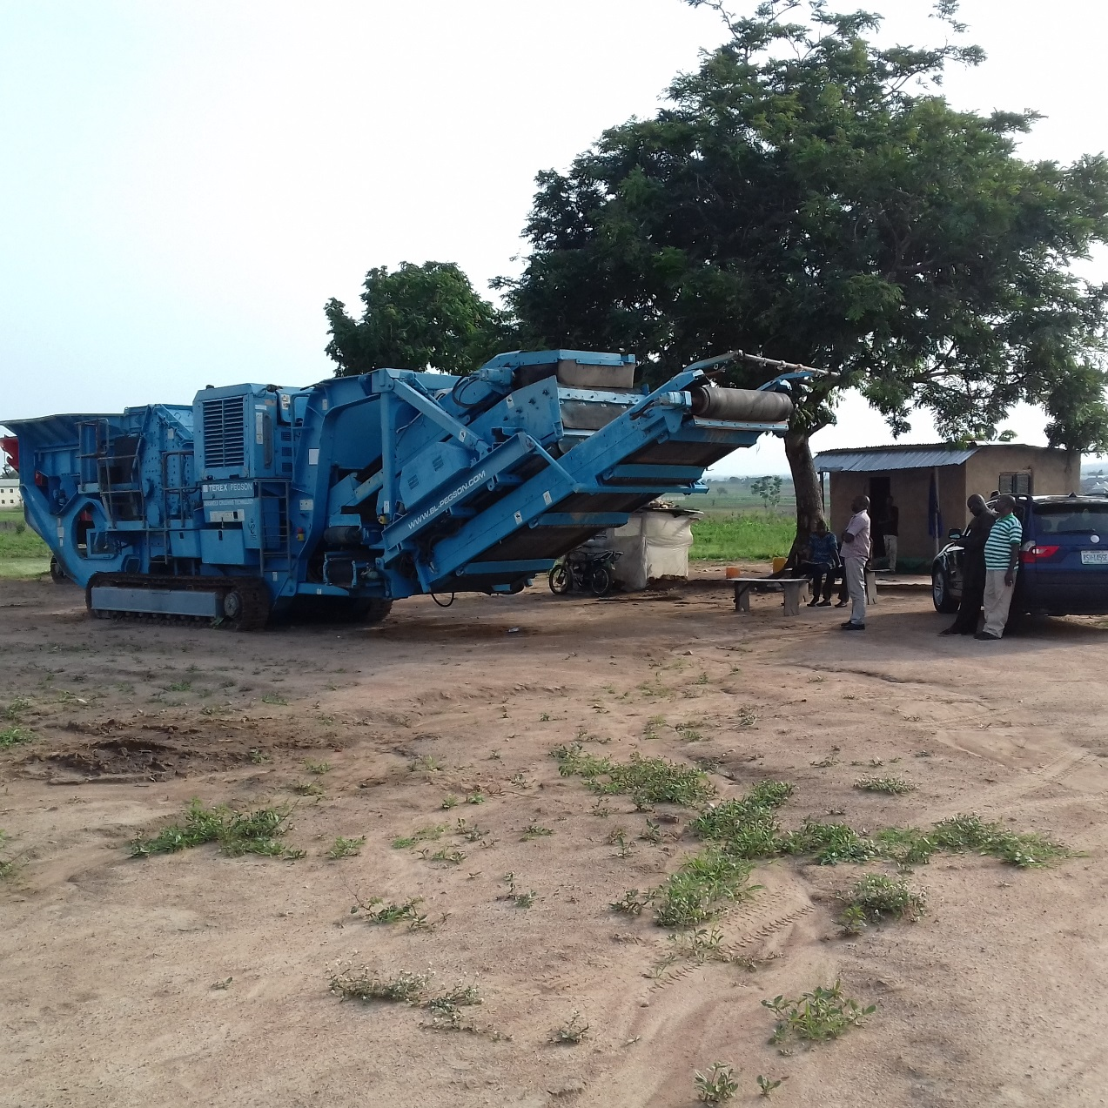

350 TPH Mobile Impact (Secondary) Crusher

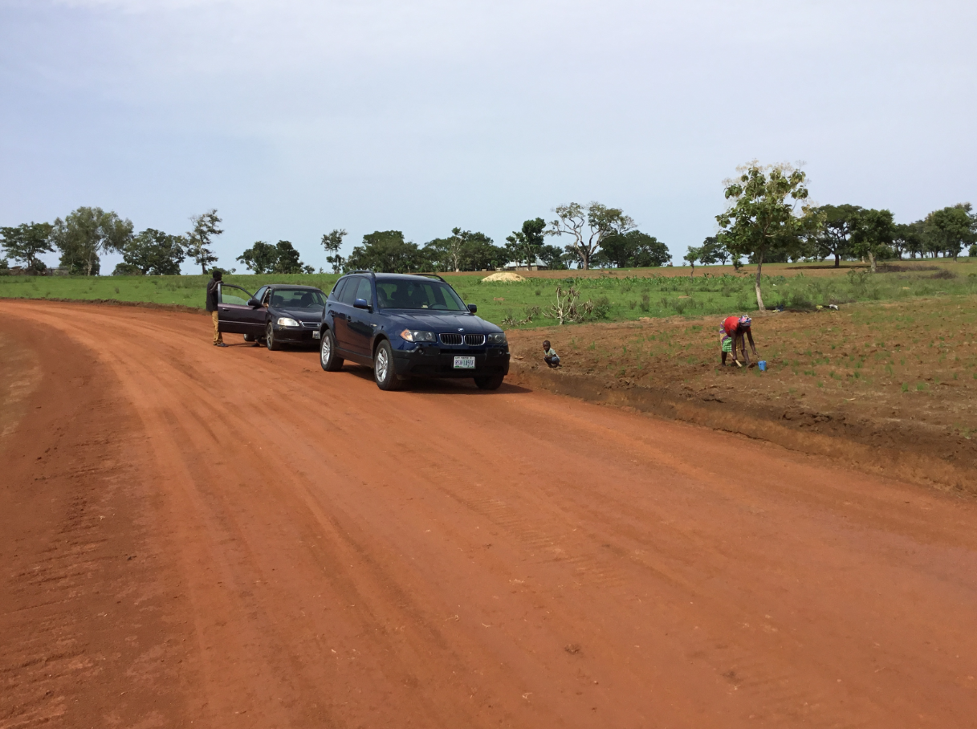

Section of constructed 1.45km Access Road to the Quarry Site

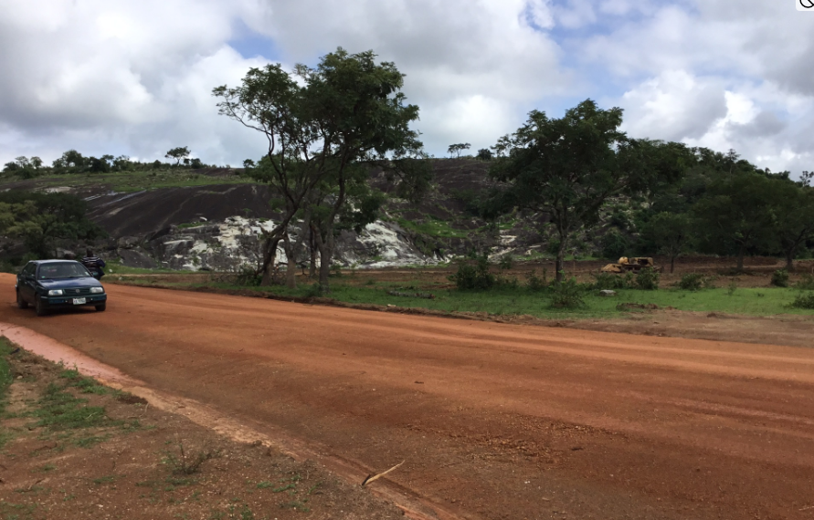

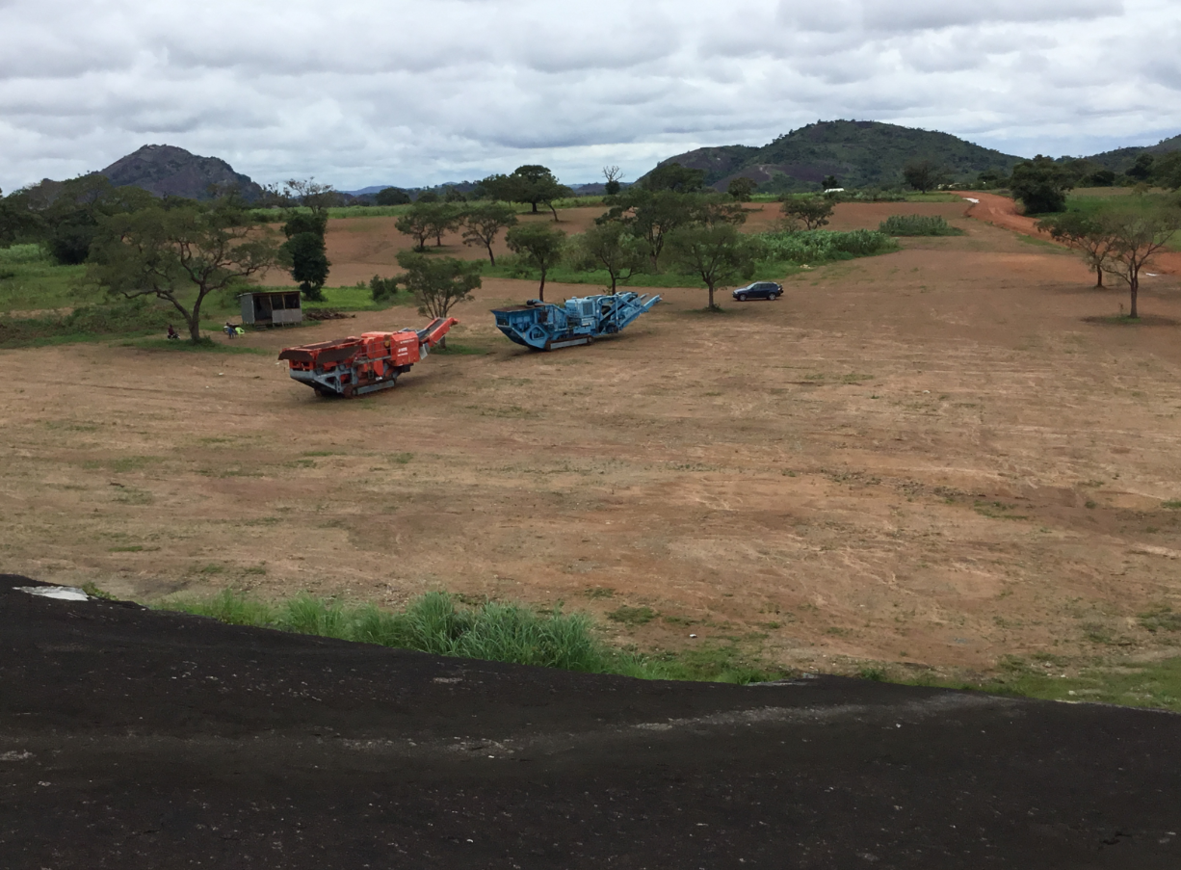

Quarry Site underconstruction and Rock to be quarried, awaiting remaining equipment

Submit this document and the photos (zip-file) to [info@naventure.se](mailto:info@naventure.se).

**Frequently Asked Questions**

What are the challenges of doing business in Nigeria and how are you/going to manage it?

*Nigeria is a country of about 180m people, Africa’s most populous and highest GDP country. The main challenges to doing business in Nigeria are access to finance, electricity and corruption. Some significant progress is being made to improve the business environment, with the country recently moving 24 points on the 2018 ranking of Ease of Doing Business (World Bank’s 2018 Report).*

*Our strategy is to maximize sweat capital, we are raising debt capital from non bank entities, because Banks will not lend to companies with no history or collateral to back them. To address electricity supply, the crushers have their own power units, floodlights will be solar powered, and consequently the electricity requirement will be reduced. To deal with corruption issues, we are committed to full compliance of all regulatory and tax obligations, and define an identity of an ethical and respectful company. Selling aggregates prepaid will mitigate the risk of unpaid supplies that can create a situation of extortion, out of desperation to collect account receivables. We are a company founded and committed to living out ethical and biblical values in the marketplace.*

Do you have a team that is competent to manage the business and deliver the business?

*The organization is resourced with competent and experienced people at management level. Our collective experience is diversified across the quarry and allied industries. The combined depth of experience of the CEO (working experience in the maturation and execution of oil and gas projects avails the company on expertise in risk management, resource volume estimation, development planning, integration and operations) and the Quarry Manager, a strong HR and Accounting/Finance functions resources the organization for effective management. We are developing HR and operational policies, systems and processes for the effective operation of the company. As a new company we are careful to ensure we start on the right footing.*

*The pillars of our effectiveness will be in people management, asset integrity/maintenance and commercial focus. No company no matter how well-endowed has all the resources it needs in house. We are building partnerships across suppliers, professional services and customers to support the company operations.*

How are you financing the business?

*The company is funded through equity from shareholders, debt capital from individuals (friends and colleagues) and entities. The debt capital is a mix of short and long term, with short term debt dominating. Our focus going forward is to target long-term debt in the short-term and equity capital at a later stage, when we would have a track record to demonstrate capacity and profitability.*

How will your team use capital for continuous profitability?

*The capital raised is primarily deployed to asset acquisition and we are driving efficiencies to keep overheads and operating cost under control. We have looked at the scenarios and concluded that being heavy on equipment acquisition and low on leasing is more capital efficient in our environment. This strategy is underpinned by the ground reality.*

What is your business strategy and what are the unique selling points?

*Aggregates are the major raw materials of all construction projects (highways, bridges, buildings, airports, railroad beds, etc.) and the infrastructure industry. They “make up 94% of asphalt pavements and 80% of concrete”. And “it is estimated that it takes 38,000 tons of aggregates to construct one lane mile of a four-lane interstate highway” (NSSGA). Nigeria has a massive infrastructure deficit, with 194,000 kms of highway, with only 18% paved, and with over 17m housing deficit.*

*Our strategy is to target this critical component of the industry that is needed by every project. It is typically in high demand, with a demand pull and traditionally a prepaid product - not a credit business. Aggregates delivery cost to our operational area is often delivered at 50-100% cost of the products, because the closest quarries are over 100km away. Given the significant freight cost component, the use of mobile crushers allows us to deliver on demand, captive crushing near client’s project sites, thus driving cost and time efficiency. Furthermore, aggregates crushing provides a platform for future growth through value added verticals like concrete batching, concretes products production and asphalt batching. We are structured to provide customized service and located our first quarry in an area where products are supplied from some 100-190kms away.*

Who are your target customers and the potential for the growth?

*Our target customers are made of mid size contractors (who cannot set up quarries) executing intercity and township road projects in the southern part of Kaduna State, to whom our location offers them speedy and cheaper supply on account of distance. There is also a major township development in the fringes of Abuja. This category of customers require significant quantity of products. We will maximize this segment by ramping up production when demand is high to mitigate periods when their funding slacks. Where necessary and profitable, we will provide captive crushing close to project sites, by leveraging our mobile crushers.*

*The second segment are sandcrete blocks/bricks makers and individual housing projects that will be sold via distributors. Nigerians typically construct their own homes, and the standard material is sandcrete or concrete blocks. Block perimeter walls are integral to every house project.*

*Future growth will be in terms of growing capacity for captive crushing and adding value to aggregates by using products to produce concrete products and asphalt batching. To avert the risk of unpaid invoices and bribery associated with contracts, we will not take on construction contracts.*

Who are the competition and how do you remain competitive?

*Our competitors are 190kms away in Kaduna, 100kms away near Keffi and 160kms away in Jos. The southern part of Kaduna State has no single quarry.*

*Our competitiveness comes from our ability to deliver cheaper, from freight cost savings and faster, thus helping shorten project delivery timelines as well as reducing carbon footprint. A capable team with industry experience that is committed to outthinking and outperforming the competition. We operate a servant leadership model and keep our employees welfare and competence at the heart of our business. We are also committed to pursuing excellence in our operation and maximizing the use of technology to enhance our operations.*

*A number of quarries have shut down because of management issues from either owners, management team or both. We have reviewed the causes of the failures of quarries, undertaken risk analysis of the technical, economic, commercial, operational and people risk and put mitigations in place, supported by an organizational design that will be fully resident at the quarry location.*

What have you learnt from our competitors’ mistakes?

*Quarries set up without thorough feasibility studies and business plan, owner manages who micro manage and do not fund operations, management teams that mismanage and ground the operations, poor maintenance of equipment, non-compliance of regulatory obligations – payment of royalties, etc.*

In What ways will the company operations create social and economic impact?

*The Quarry operations will be the only major economic activity around the area. At full capacity, we will have 35 employees. We will seek to maximize local patronage of goods and services, and will offer product distributorship to people from the area. Taxes will accrue to the state in the form of VAT and pay as you earn (employees) tax.*

*A community development plan will be an integral part of the operation, with focus on capacity building and infrastructure. A 1.45km earth road has already been constructed. Furthermore, we plan to invest in entrepreneurial training by supporting Itzinya Start Up Academy in Abuja and 3 mission agencies.*

What are the environmental impacts of your operation and how will you manage it?

*The environmental impact of quarrying ranges from dust and noise pollution, loss of agricultural land, CO2 emission and traffic. As a policy the design and choice of explosives for blasting is based on the low noise explosives, supported by proce**dures. The two crushers are fitted with water sprinklers on the output conveyors to reduce dust. We have been prudent with land take and full compensation has been paid on lease, the process was facilitated by community leaders and mutually agreed. To reduce carbon footprint, we plan to use solar flood lighting and also maximize our production capacity through the efficient feeding of the primary crusher achieve upto 300 TPH.*

1. Full-time - at least 35 hours/week. Sum up everyone that get salaries from the company where e.g. two persons working half-time is regarded as one full-time employee.